
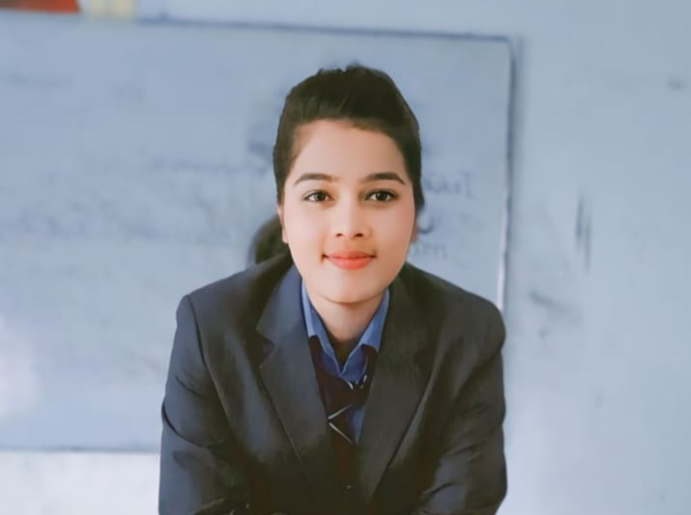

PROFIL

I like always challenging work with my own faith. I have confidence to fulfill the challenges.

CONTACT

PHONE: 9520938415

EMAIL:
jigyusharma2830@gmail.com

HOBBIES
Academics: Group Discussion, Presentation.
Co-curricular: Web surfing, browsing, Observing reobserving Books.

EXPERINCE
Fresher

JIGYISHA SHARMA

EDUCATION

10th CBSE Board 2021

12th CBSE Board 2023

BBA Complete

PERSONAL STRENGTHS:
Self-motivated, Good problem-solving ability, Self-driven, ability to work independently, Competitive and passion for winning Leadership, Consultant

PERSONALITY TRAITS:
Ability to perform under tough challenging conditions Team player and capable of managing group dynamics

PERSONAL DETAILS:
Date of Birth: 28-06-2005
Father’s name: Mr. VIPIN SHARMA Gender: Female
Current Address: Village Lahchora Distt – Baghpat.
Marital status: Unmarried
Nationality: Indian Language Known: Hindi & English

